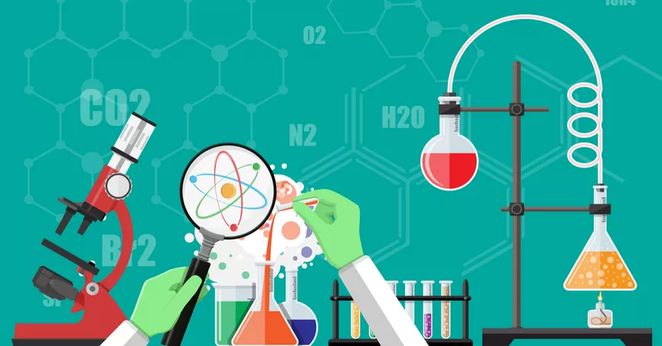
High School Science Lab Schedule
Fall 2018

Teacher: Mr. Carmean
When: Every other Tuesday
Time: 2:30-4:00
Where: D69

Tuesday, August 21st - Welcome to Science Lab!
Tuesday, September 4th
Tuesday, September 18th
Tuesday, October 2nd
Tuesday, October 16th
Tuesday, October 30th
Tuesday, November 13th
Happy Thanksgiving!
Tuesday, November 27th
Tuesday, December 11th - Final Lab
Happy Holidays!
*Dates are subject to change - please sign up for Remind101 to stay informed.

